# Image result for srm logo downloadSRM Institute of Science and Technology- Ramapuram campus

Department of Mathematics

18MAB204T- Probability and Queuing Theory

Year/Sem: II/IV Branch: CSE, IT

**Unit I - PROBABILITY AND RANDOM VARIABLES**

**PART-B**

1. A lot consists of 10 good articles, 4 with minor defects and 2 with major defective. Two articles are chosen from the lot at random (without replaced). Find the probability that both are good.
2. 3/8 (b) 7/8 (c) 5/8 (d) 1/8

Answer: a

Solution:

P (both are good)= $\frac{No. of ways drawing 2 goods articles}{total no.of ways of drawning 2 articles}$

$$=\frac{{10C}_{2}}{{16C}_{2}}=\frac{3}{8}$$

2.

2

1. 46 (b) 64 (c) 66 (d) 66.5

Answer: c

Solution:

We knoe that $var(aX+bY)=a^{2}var\left(X\right)+b^{2}var(Y)$

$$var\left(3X+4Y\right)=3^{2}var\left(X\right)+4^{2}var(Y)$$

$$=9*2+16*3=66$$

3.

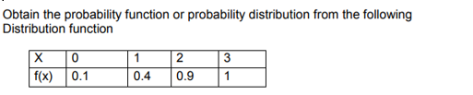

|  |  |  |  |  |
| --- | --- | --- | --- | --- |
| X | 0 | 1 | 2 | 3 |
| P(x) | 0.1 | 0.3 | 0.5 | 0.1 |

(a)

|  |  |  |  |  |
| --- | --- | --- | --- | --- |
| X | 0 | 1 | 2 | 3 |
| P(x) | 0.1 | 0.4 | 0.5 | 0.1 |

(b)

(c)

|  |  |  |  |  |
| --- | --- | --- | --- | --- |
| X | 0 | 1 | 2 | 3 |
| P(x) | 0.1 | 0.3 | 0.9 | 0.1 |

(d)

|  |  |  |  |  |
| --- | --- | --- | --- | --- |
| X | 0 | 1 | 2 | 3 |
| P(x) | 0.1 | 0.3 | 0.5 | 1 |

Answer: a

$$P\left(x=0\right)=f\left(0\right)=0.1$$

$$P\left(x=1\right)=f\left(1\right)-f\left(0\right)=0.4-0.1=0.3$$

$$P\left(x=2\right)=f\left(2\right)-f\left(1\right)=0.9-0.4=0.5$$

$$P\left(x=3\right)=f\left(3\right)-f\left(2\right)=1-0.9=0.1$$

4.

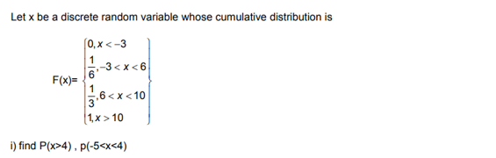

$p\left(x>4\right)=\frac{1}{6}, p\left(-5<x<4\right)=\frac{1}{8}$

$p\left(x>4\right)=\frac{1}{6}, p\left(-5<x<4\right)=\frac{1}{6}$

$p\left(x>4\right)=\frac{1}{8}, p\left(-5<x<4\right)=\frac{1}{8}$

$p\left(x>4\right)=\frac{1}{6}, p\left(-5<x<4\right)=\frac{1}{7}$

Answer : b

Solution:

$$P\left(x<4\right)=P\left(x=0\right)+P\left(x=3\right)=0+\frac{1}{6}=\frac{1}{6}$$

$$P\left(-5<x<4\right)=F\left(4\right)-F\left(-5\right)=\frac{1}{6}-0=\frac{1}{6}$$

5.



1. 33 (b) 44 (c) 66 (d) 36

Answer: d

We know that

6. The first four moments of a distribution about A = 4 are 1, 4 , 10 , and 45 respectively.

Find the value of $μ_{1 , }μ_{2 ,}μ_{3 and }{ μ}_{4}$.

(a) $μ_{1=5 , }μ_{2=3 ,}μ_{3=0 and }{ μ}_{4=26}$

(b) $μ_{1=3 , }μ_{2=5 ,}μ_{3=0 and }{ μ}_{4=26}$

(c) $μ_{1=5 , }μ_{2=3 ,}μ_{3=26 and }{ μ}_{4=6}$

(d) $μ_{1=5 , }μ_{2=3 ,}μ_{3=0 and }{ μ}_{4=6}$

Answer: a

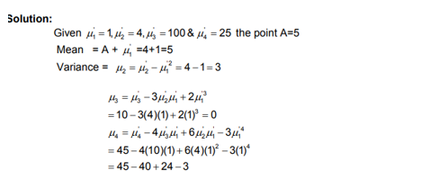

7.



(a) $p\left(x=1\right)=\frac{15}{60} ,p\left(x=2\right)=\frac{9}{60}, p\left(x=3\right)=\frac{30}{60} ,p\left(x=4\right)=\frac{6}{60}$

(b) $p\left(x=1\right)=\frac{20}{66} ,p\left(x=2\right)=\frac{10}{66}, p\left(x=3\right)=\frac{30}{66} ,p\left(x=4\right)=\frac{6}{66}$

(c) $p\left(x=1\right)=\frac{15}{62} ,p\left(x=2\right)=\frac{10}{62}, p\left(x=3\right)=\frac{30}{62} ,p\left(x=4\right)=\frac{7}{62}$

(d) $p\left(x=1\right)=\frac{15}{61} ,p\left(x=2\right)=\frac{10}{61}, p\left(x=3\right)=\frac{30}{61} ,p\left(x=4\right)=\frac{6}{61}$

Answer: d

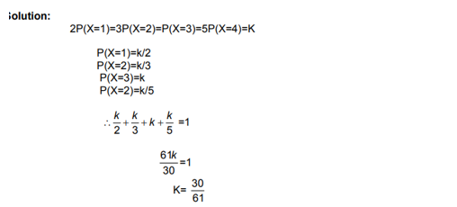

|  |  |  |  |  |
| --- | --- | --- | --- | --- |
| X | 1 | 2 | 3 | 4 |
| P(X) | 15/61 | 10/61 | 30/61 | 5/61 |

8.



$\frac{1}{π}\left(\tan^{-1}{x+\frac{π}{2}}\right)$

$\frac{1}{π}\left(\tan^{-1}{x-\frac{π}{2}}\right)$

$\frac{1}{π}\left(\tan^{-1}{x+\frac{π}{4}}\right)$

$\frac{1}{π}\left(\tan^{-1}{x+\frac{π}{6}}\right)$

Answer: a

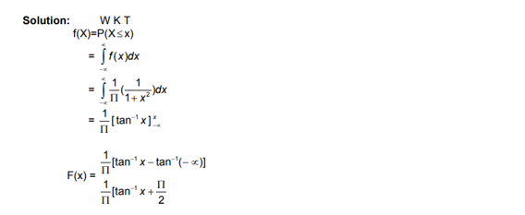

9. A random variable X has $μ=12$ and $σ^{2}=9$ and unknown probability distribution.

Find $(6<X<18)$.

(a) $P(6<X<18)≥\frac{3}{4}$ (b) $P(6<X<18)≤\frac{3}{4}$ (c) $P(6<X<18)≥\frac{1}{4}$ (d) $P(6<X<18)≥\frac{6}{8}$

Answer: a

Solution:

Lower bound for the probability by using Tcebycheffs inequality

$$P\left\{\left|X-μ\right|≤c\right\}≥1-\frac{σ^{2}}{c^{2}}$$

$P\left\{μ-c≤X≤μ+c\right\}≥1-\frac{σ^{2}}{c^{2}}$ taking $μ=12 and σ=9 ,we get$

$$P\left\{12-c≤X≤12+c\right\}≥1-\frac{9}{c^{2}}$$

Putting $c$ =6 $P\left\{6≤X≤18\right\}≥1-\frac{9}{36}=\frac{3}{4}$

10.



(a) $1-e^{-x}(x-1)$

(b) $1+e^{-x}(x+1)$

(c) $1-e^{x}(x+1)$

(d) $1+e^{-x}(-x-1)$

Answer: d

11.

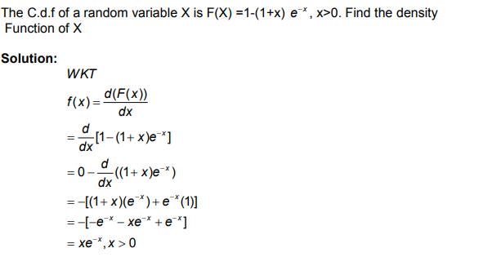

12. There are 20 boys and 15 girls in a class of 35 students. A students is chosen at random find the probability that the chosen students is a (i) boy (ii) girl

Solution

$$n\left(s\right)=35, n\left(B\right)=20, n\left(G\right)=15$$

Probability of choosing a boy is $P\left(B\right)=\frac{n(B)}{n(S)}=\frac{20}{35}$

Probability of choosing a girl is $P\left(G\right)=\frac{n(G)}{n(s)}=\frac{15}{35}$

**13.**

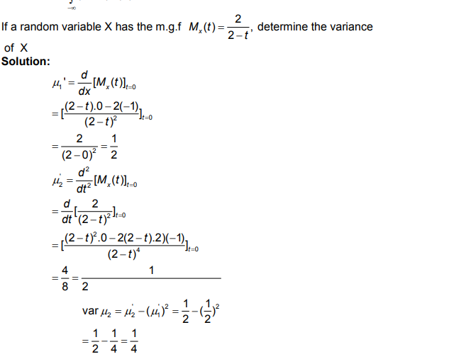

**14.** A continuous random variable X has the distribution function  Determine k

and the pdf.

**Solution:**



**15.**The diameter of an electric cable X is a continuous R.V with PDF

.Find the (i) value of ‘ k ‘

**Solution**



**16.** Find the m.g.f and the r th moment for the distribution whose p.d.fis f(x) = k e-x, 0 < x <∞. Find also the standard deviation.



**17** Let X be a random variable with p.m.fFind the m.g.f of X.



18. (i) Find the moment generating function of the continuous probability distribution whose density is $2e^{-2x},x≥0$ also find first four raw and central moments.

Solution :

**(i)** Given f(x) = $2e^{-2x},x≥0$ we know that $e^{-∞}=0 \&e^{0}=1 M_{X}\left(t\right)=E\left[e^{tX}\right] = \int_{0}^{∞}{e^{tx}}2e^{-2x}dx$ = 2 $\int_{0}^{∞}{e^{-x\left(2-t\right)}dx}$ = $2{\left\{\frac{e^{-x\left(2-t\right)}}{t-2}\right\}}_{0}^{∞}$

${ M}_{X}\left(t\right)=\left(\frac{2}{2-t}\right)$ = ${\left(1-\frac{t}{2}\right)}^{-1}$

= $\left(1+\frac{t}{2}+{\left(\frac{t}{2}\right)}^{2}+{\left(\frac{t}{2}\right)}^{3}+{\left(\frac{t}{2}\right)}^{4}+{\left(\frac{t}{2}\right)}^{5}…\right)$-------- (1)

${ M}_{X}\left(t\right)=\left(1+\frac{t}{1}{µ_{1}}^{'}+\frac{t^{2}}{2}{µ_{2}}^{'}+\frac{t^{3}}{3}{µ_{3}}^{'}+\frac{t^{4}}{4}{µ_{4}}^{'}+\frac{t^{5}}{5}{µ_{5}}^{'}+…\right)$-------- (2) comparing (1) & (2) we get the first four raw moments ${µ_{1}}^{'}=\frac{1}{2}$, ${µ_{2}}^{'}=\frac{1}{2}$, ${µ_{3}}^{'}=\frac{3}{4}$& ${µ_{4}}^{'}=\frac{24}{16}$ and the first four central moments $µ_{1}=0$, $µ_{2}={µ_{2}}^{'}-{\left(µ_{1}^{'}\right)}^{2}$ = $\left(\frac{1}{2}\right)-{\left(\frac{1}{2}\right)}^{2}=\frac{1}{4}$,

$$µ_{3}=µ_{3}^{'}-3µ_{2}^{'}µ_{1}^{'}+2{\left(µ_{1}^{'}\right)}^{3}=\frac{3}{4}-3\frac{1}{4}+2\left(\frac{1}{4}\right)=\frac{1}{2}$$

$$µ_{4}=µ_{4}^{'}-4µ_{3}^{'}µ_{1}^{'}+6µ_{2}^{'}{\left(µ_{1}^{'}\right)}^{2}-3{\left(µ_{1}^{'}\right)}^{4}=\frac{24}{16}-4\left(\frac{3}{8}\right)+6\left(\frac{1}{8}\right)-3\left(\frac{1}{16}\right)=\frac{9}{16}$$

19.A discrete random variable X has M.g.f = $M_{X}\left(t\right)={\left(\frac{1}{4}+\frac{3}{4}\right)}^{5}$ find E(X) , Var (X) and P(X=2)

The given m.g.f $M_{X}\left(t\right)={\left(\frac{1}{4}+\frac{3}{4}\right)}^{5}$ is of the form $M_{X}\left(t\right)={\left(q+pe^{t}\right)}^{n}$ which is the m.g.f of the Binomial distribution whose p.m.f is P(X=x)= , mean E(X) = np and Variance = npq

Here q = $\frac{1}{4}$, p = $\frac{3}{4}$ and n = 5

=> P(X=2)=

Mean , Var(X) =

20. Find the cdf for the following pdf f(x) = 



